An Analysis of The Peninsula Fine Arts Center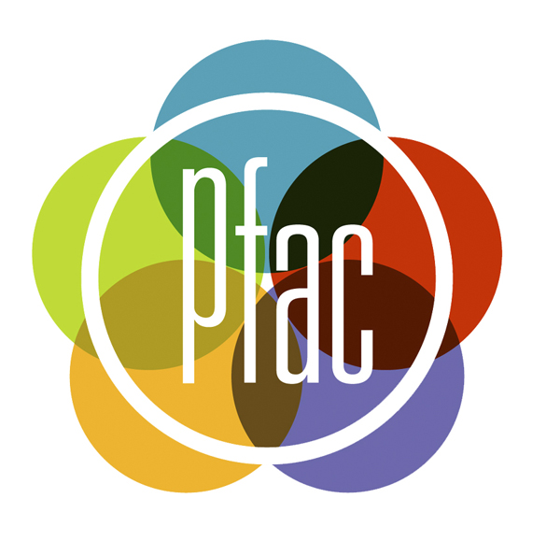

Sarah Crouse
Mar’tina Hampton
Mary Ragan
Wintie Tewolde
Ebony Tyler
BUSN 340
Spring 2012
Table of Contents
Non-Profit as Business Enterprise Analysis

- Executive Summary
- Introduction
  - Non-Profit History, Background, Key Personnel
  - Non-Profit Mission, Vision, Values, Outreach and Success
- Purpose and Objectives of The Peninsula Fine Arts Center Report
- Description of Methodology
  - Overview/ Description of Diagnostic Business Tools
    - Mission Statement
    - Website Matrix of Comparable NPOs
    - Observation and Interaction
      - Site Visits
      - Interviews/Surveys/Focus Groups
    - SWOT Analysis
      - Initial
      - Interim
      - Final
    - Ethics Code
    - Legal Audit Checklist
    - Strategic Planning Guidelines
  - Overview/Description/Findings of Functional Areas of Non-Profit
    - Accounting
    - Financial
    - Management- HR
    - Management- Operations
    - Marketing
    - IT
    - Legal and Ethical
- Recommendations and Suggested Implementations
  - Priority Recommendations
  - Long-Term Recommendations
- Conclusion
- Appendices
  - PowerPoint
  - Charts, Graphs, Flow Charts
  - Website
  - Other Documents

Executive Summary

This business analysis report was established for Christopher Newport University’s Business 340 course; a course focused upon studying non-profit organizations as business enterprises. This report is an analysis of the Peninsula Fine Arts Center, a non-profit organization dedicated to creating and exhibiting artwork, in addition, to advocating the importance of art to the local Hampton Roads community. This analysis includes an assortment of diagnostic tools such as a website comparison matrix, SWOT analysis of the Peninsula Fine Arts Center, and interpretation of findings of the Seven Sisters of a Non-Profit Organization: Accounting, Finance, Management- Human Resources, Management- Operation, Marketing, IT, and Legal & Ethical. After final analysis and interpretation of the organization, priority recommendations and long-term recommendations were made to the Peninsula Fine Arts Center to enrich their organization and assist in its continued success and perpetuity.

Non-Profit History, Background, Key Personnel

The Peninsula Arts Association (PAA) was started in 1962, becoming the Peninsula Fine Arts Center (Pfac) in 1983 and also declared an Affiliate of the Virginia Museum of Fine Arts. The center was founded on the democratic belief of “the celebration of the individual’s voice and the power of people when they come together and understand each other’s similarities and differences through art.” It was stared by a small group of local volunteers dedicated to seeing what art could do in the Hampton Roads community. In fact, Agnes McMurran Johnson was a key contributing founder.

The location of the center changed around from the former John W. Daniel School Building, Christopher Newport College, Hilton Village, and the Newmarket South Shopping Center. In 1975 Newport News Shipbuilding donated its former hydraulics testing laboratory, located on two acres of land across from the Mariners’ Museum. The facility opened in 1978. In 1985 David L. Peebles took on the role as chairman of the Capital Campaign in order to raise $1.5 million for Pfac to add on another wing to its center. Major additions to the center were added, creating many benefits to further the center in its outreach and productivity within the community.

In 1993, Pfac established accreditation by the American Association of Museums, which entails a difficult process. Pfac has had close to 500 exhibitions including varied things such as holiday invitationals, juried shows, curated shows, and college competitions. In fact, there is currently work by Christopher Newport University students on display at Pfac. In 2012, Pfac is celebrating its 50th Anniversary, which it will do through various exciting exhibitions including “Art and the Animal,” and “The Artists: Who We Are Past and Present,” which provides a history of Pfac and the Virginia Peninsula through photographs.

Pfac has seven people on staff, including Courtney Gardner as the executive director. Michael Andrew Preble is the Program Director and Curator, and Mike McGrann is the Marketing Director. In addition, Becky Fitchett is the volunteer coordinator, another very important role. Pfac also has three to four interns at a time, in addition to over 100 volunteers. Pfac is continually working towards broadening its outreach and playing an effective and crucial role in the community.
(2011). Peninsula fine arts center. Wikipedia, The Free Encyclopedia. http://en.wikipedia.org/wiki/Peninsula_Fine_Arts_Center

Mission, Vision, Values, Outreach

Mission: “To provide a balanced and stimulating program of visual arts, through dynamic exhibitions and educational programs”

The mission of a non-profit organization defines and drives the organization. The mission statement of the Peninsula Fine Arts Center is accurate, however, the organization may be making changes to this statement in the future. To assist with this process, please see our suggested mission statement located on page 7.

Vision: PFAC’s vision is to serve as a cultural leader in the Hampton Roads community and serve as a catalyst for change. Building community partnerships, innovative programs, and working to tear down economic, cultural, and geographic boundaries, PFAC is a premier authority on visual arts and strives to serve as a social center for the community through its dynamic exhibitions, educational programs, and events.

Outreach and Success: The Peninsula Fine Arts Center is the premier arts advocate in the region working to create a stronger community through art. Experience the arts through changing exhibitions, thought-provoking educational programs, a year- round studio art school, an interactive gallery for children, art happenings and family friendly activities.

Purpose

The purpose of this analysis is to explore and understand the organizational practices of a local 501 ( c ) (3). The members of this group, via assistance by Brad Brewer in the Center for Community Engagement, have chosen the Peninsula Fine Arts Center in Newport News, Virginia. This organization will be analyzed using methods such as the Seven Sisters (Accounting, Finance, Management Human Resources, Management Operations, Marketing, IT, and Legal and Ethics), SWOT analysis (Strengths, Weaknesses, Opportunities, and Threats), Website Matrix, Site visitations, and Interviews. Using these components of evaluation, our group members will be able to understand, reflect, and report on our findings. Serving as a requirement for the Civic Engagement and Social Entrepreneurship program of which we are each participating, the outcomes of this project will be beneficial to the Peninsula Fine Arts Center and each member of our group.

Mission Statement

“To provide a balanced and stimulating program of visual arts, through dynamic exhibitions and educational programs.”

This mission statement is the current public statement located on the online resources the Peninsula Fine Arts Center uses. Executive Director Courtney Gardner emphasized to us PFAC’s need to create an updated mission. Their organization is currently in the midst of this process. Our group encouraged this based on the heighted importance of an effective mission statement. A mission statement guides the values and activities that define an organization. Mission statements are also important for financial reasons. Unrelated Business Income Taxes are taxes on spending that do not relate to the mission the organization declared. This tax stresses the importance of a well thought out and purposeful mission. We encourage PFAC to take ample time, and energy working through their future mission, and hope that our analysis will assist them in this process. We have also suggested the following mission statement:

“The purpose of the Peninsula Fine Arts Center is to be a resource for local artists to display their work, community members to enjoy various forms of art, art education for students in elementary, secondary, and collegiate levels, and to create a stronger community through art.”

Website Comparison Matrix

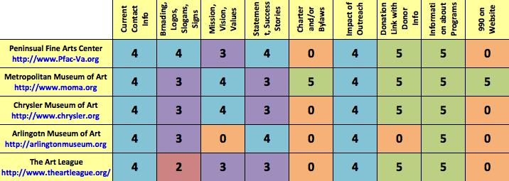
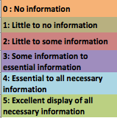

Site Visits, Interviews/ Surveys

We have visited the Peninsula Fine Arts Center on three separate occasions. We have spent time speaking with Joan, the front desk assistant who has been working at Pfac for 23 years, and Courtney Gardner, the executive Director of Pfac. The transcript of our interviews with Courtney are seen below:

Visit- Wednesday, March 28th at 2 pm
Peninsula Fine Arts Center Conference Room

Can you clarify the mission of PFAC?
“I just started in November… We are in the process of reviewing that…none of us really quite know what the mission is! We have value statements, not a mission.”

How do you reach success?
“We are starting to look at the question, how do you figure out if you’ve been successful? I believe each time you do what ever it is you are planning; you need to know what outcome goals you wish to achieve. A nonprofit’s success is based on its relevance. Are we reaching our community? Is our membership growing? Are we meeting the needs of our community? We’ve been surveying Programs- art after 5. We have been asking, what other things would you like to see us do? We want to be relative for arts as a whole- poetry nights, etc. But what we have found is that it’s an opportunity for fellowship, we are here to interact with each other. We need to incorporate visual arts into that.”

If you could wave a magic wand and change 1 thing about Pfac, what would it be?
“Funding. What we are seeking to achieve is to be the place. We want to be relevant to the community and the local arts community! For our 50th we are trying to reenergize that. It started with Angus Johnson. She used to do exhibits in her back yard, they would hang art works on their clothes lines! They just wanted a place to show their work! That is still important! It would be for the community to want to see that. And students shouldn’t have to guess. I would love to have a place to show artists while working. Like studios where people could watch. Some artists would like it! They are just as excited as you are! You would find that the arts that rented studio space would probably love that!”

Do you have a strategic plan?
“We have one! I think it’s very similar to others, it’s not a living document. I’ve been in nonprofits for 16 years, that’s not unusual. In nonprofits You get caught up in the world of day to day. In for profits they are focused on the bottom line, we are more focused on the work we do. We are the same thing we were in 1962 when we started. A place to allow local, national, and international artists to display their work and allow the community to give feed back and for school children to learn through that art.”

Why are the programs that you offer vital to our community?
“Schools are cutting arts programs. We have a permanent gallery called hands on for kids, every 3 and a half months our shows change out. There is a family activity center, in hands on for kids and we have one free weekend a month and have family centered activates the first Saturday of the month. Art access- it is an opportunity for area school children to experience art, we take them into the class room to make them come adhere and once they come here there are activities. We have a high school program with a show and awards. Same for colleges. Artistic verses- creative writing classes in nnps. They write about the art they see. It is in school, they come here and work with a poet and a theater artist to prepare. It is important to deliver! See the importance of the spoken words. BAM portfolio!”

Do you work with downin gross?
“I was on the board there. I will be anxious to see the work installed there.
We don’t have joint programs- we got the building in 1975, there used to be “the guild” a ladies group. Pfac came out of ladies in the junior league. They used to be community shows in the folk gallery. Those are left over from when they did shows. The winning piece was saved by cnu. We were in that little building at Hilton village. Out of being angry with the mariners, they gave the building to us! This was a gifted location- it’s a blessing a curse! It is a gorgeous building but it’s tucked away, its next to a place that we are not a part of!! We don’t have enough money to market a way out of that. Our marketing director is really great but he has no budget. He is just great with building relations. Image how good they’d be with money! The mariners museum has gone down, and so has us. Our entrance is beautiful but hidden!”

Do you have a Code of ethics?
“No. not that I’ve run across. I belong to the association to fundraising professionals. So there is one for them. So there are standards by virtue by being an accredited arts foundation. Must keep temperate perfect! We take work in and it belongs to us! We have to keep it in the status that is meant to be. Art institutions function like any other museum. One of the bad things is allowing food and drink. So we try not to avoid it because we need to be outside.”

Do you have an annual newsletter?
“No. But we are required by our bylaws to inform our membership with an update on the status of our organization. We present a state of the organization to all the members to save costs. The most dramatic shift this organization went through in 2002 their state funding was eliminated. $3000 and I don’t think we truly ever recovered. We are looking at. There are 3 main funding sources. Individual, foundation, corp. grants/ governments and Earned revenue. Our earned revenue is lacking. The largest is the studio art schools, but we can only have 5 studios. We are limited by how many people we can serve.”

Visit- Tuesday, April 10th at 4pm
Peninsula Fine Arts Center Conference Room

What do you do with the donor information you gather?
“We use mailing lists. We do a dual process- we do the vast majority of our outreach isby email. Our active mailing list is 1,523. Email is even bigger. We send out Pfac news on a routine basis. We are on Facebook pretty routinely. What we do with our pfac news is driving our traffic towards the website, that’s more cost effective. We snail mail for events or invites, but not generally as outreach for news.”

How many donors and what levels?
“We have different levels. Individual member at $40, family member is $60, curiorator is $150, director 5$00, president any gift over thousand.”

How many pieces of work do you have in the building at one time?
“Changes show by show- that varies every exhibit.”

Do you have any Legal council?
“We have a board member who is an attorney that we run things past and we outreach to former board members but we do not have official legal council. We do that ‘in- kind’.”

Do you use Newspapers, commercials etc?
“WHRO has an ongoing advertising relationship with the public radio and television station. Always a goal. We pay 25 cents on the dollar for what we get out of the station. They go above and beyond that. That is the only ongoing thing. With daily press it’s a complete partnership, we will have a ¼ page ad in the Sunday paper for the art after 5 thing. It isn’t an all my eggs in one basket thing. The money just isn’t there to go on Rush Limba. But as far as paid placement, it’s a stretch. As though our marketing budget has always been meager- but I am always willing to sustain the institution to take money out and give it to the rest of the company. The budget is so small to begin with- we cant do an effective marketing campaign. We have a regional presence a local presence. Ad dollars should be better used locally, not nationally- thus no Rush Limba. Your audience is driving off your product offerings. Did marketing for eddie bower- life style branding, look at things as products, “what we are selling here is an experience” we feel you should incorporate this in your daily life and future plans. The benefits of being associated with us is really diff. way of approaching the branding and who the institution is and what other museums do, we aren’t about our exhibitions, we offer more products than that. We are more than just exhibits! We offer diff products more geared toward local community. That’s the wisest use of the money. That is the most strategic use of our funding. Most people who are tourists here stay! So by educating the citizens we are very likely place for people to bring their out of tow visitors. When people move into town if they have any interest in the arts we are one of the first places we come. Its not just raising our awareness and instilling the notion making pfac a crucial part of their life, but there is the anther hump that isn’t necessarily unique to pfac and that’s making people to want art to be part of their experience. Higher calling!! The opportunity is to make the experience as cool as possible. It is important to use being relevant. And its constantly being relevant to the consumer. There are a number of diff ways too achieve it but we must always seem fresh and innovated and welcoming and art after 5 is a great example. We build on that model. Local art, use it tin the future too. Working artists in studio spaces, film series, etc. other ways of attracting people are important too. “I don’t view art as a passive experience.” We have to lure them in to get them to view art. What problem are we trying to solve.- VA budgets- arts are leaving our schools in dramatic ways. Chesapeake eliminated all buses for the marching band! So for us an org that sees our selves as advocates as advocates for the arts. we see that as a dramatic problem. At a time where we have shrinking resources. If you don’t grow up having that- why would you perceive that there is any value to the art. That is the problem we will face in the future. We are fighting a group of people that see us as a nicety not a necessity. We help tourism. We are sometimes what keeps a child in school. Would you rather listen about history or see a play, go to a museum we are solving a problem that many people don’t even see as a problem.”

Describe your brand and branding style?
“The branding grew out of an organic approach. I didn’t see a cohesive branding of the institution. Fonts all over the place and not quite a cohesive image. So we worked with roust and partners- a real edgy marketing firm in the penn. They still work down in Hampton and are still functioning. They worked with credit unions and banks so this was diff for them. So they developed a logo that is still existing in our atom logo. We used the term pfac a lot and while there are still people resisting that. It’s an hold habit to break out of. I love that I use pfac a lot. I usually like to say the entire phrase at the beginning. But the circle with the upper and lower pfac is wholly organic that the colors can change. They put together a series of 20 variations of that. They had put part of the goal of the branding which is something id like to see us go back to is to give them basic logo to artists and have them make original works using the upper and lower case. We had a huge response and a number of really cleaver solutions that artists came up with. Then after using that for a while. Rostin came up with the pfac atom. That really shows the diff. facets of what pfac was through colors and you can rationalize that as many diff ways as you wanted to. It’s a great logo, eye catching, the only problem is that it’s difficult to use in 2 color applications, like black and white things. Still we go back to the plain circle. As far as the mark- that’s the story. With brand marketing, its because I don’t spend money on advertising, there isn’t an ongoing campaign that’s where the branding instead is reinforced. Whenever a camera is on me I always include that we are creating a stronger community through art, and I wrap it up by saying art is what you make it. That’s how it is reinforced. But the nature of the institution as it is portrayed through the brand, much of what I have been striving to do, to de-stuffy- fy them. Which is interesting because as much as the effort has been carried out. With out spending any money, they are still in our polling and questioning people, we get this elitist vision of us. So as a marketing person we do have to take to heart.it is something we are always talking about. We must go from purely the play thing of the wealthy- even though that’s never what it was, if that perception is out there , it must morph into the type of arts we peruse to display, which is a huge challenge, local artists as much as we can. We want to come back to our roots through our anniversary to o back in to our community and actively engage local artists with what we do here. And what I see as a circle of life. But that we display local artists here local artists teach here we nurture local artists through our studio art and though our college and high school juries and we sell local artists in our gallery shop so that there is an engagement in a multichannel approach in reaching local artists and making them active participants and we are constantly looking to grow. Without a resource to go and do something that I might do something that I feel we should be doing that costs money, and in order to do something things way we must bring in gorilla techniques and grass roots type of things to bring those artists in and understand we want you. To help build a stronger community through art because art is what you make it! That is the broad brush stroked. But having done generous branding campaigns. Because part of it is my old school training is what is part of a larger picture. Engage with your brand make the brand part of the life style. Just the media relations part of it is what I can do is just a small portion. Online just a piece there is always an other ingredient that is missing. I am very thankful to not only the amount of coverage we do get but the extent to which they really get it.”

How does Pfac find new employees”
“Advertise using email, word of mouth, etc. Most have been placements. Even from CNU!”

How many volunteers do you have?
“Over 100. On average they work 5 hours a week.”

How many people do you serve?
“Last year- 28,311. Total student art work- 47600. Art school enrollment- 2257. This year to day on site visits as of july 1st to dec 31st 18585- student enrollment k-12- 29294 student enrollment 731.”

Do you have any demographic information on those visitors?
“We don’t collect that info. We mimic the demographics of the populations. 56% of our visitors are Newport News residents.”

How do you a way of measuring effectiveness?
“We don’t have one, but we are starting to change that. In some ways we do and in some ways we don’t. In order to receive funding we have on site visits we say we want this many numbers by the end of the year. And we have k -12 and where we are etc. using quantitative vs qualitative measurements is a slippery slope. What we are trying to get towards is looking programmatically and looking at “what are the outcomes we are looking to achieve” that is a change we are beginning to embarking on.”

Do you have a training program for your volunteers?
“We do have docent trainings we do regularly. You are trained as you become a docent and you go through and lecture because we change exhibits. Our interns work hand in hand with out staff. We have a pretty 4 or 5 interns working at any given semester. 2 or 3 in marketing.”

Interview with Intern now Employee Theodore Fotiou
Former CNU Student
Via email

Do you feel Pfac is achieving their mission?
“To a degree, yes. We do the best we can. There are a number of people who still don't know we exist and think we're a part of The Mariner's Museum. Our location is an issue, but many people still come here to see the art, participate in or host events, and attend our classes.”
Do you think Pfac's marketing efforts are effective?
“To a degree, yes. We do the best we can. There are a number of people who still don't know we exist and think we're a part of The Mariner's Museum. Our location is an issue, but many people still come here to see the art, participate in or host events, and attend our classes.”
Would you encourage other CNU students to intern for Pfac?
“Yes, I would. I started interning here a couple months after I graduated from CNU last May. This was my first internship, and I regret not interning here as a student. With the economy in a bad place, jobs are hard to come by, but despite our limited budget, Pfac has provided me with a minor job, where I, practically, run the Center on evenings and weekends.”
“The work you do here, especially as an intern, is great to put on the resume in this very competitive economy. You need every edge you can acquire, even if you're working for free for an extended period of time. Experience is very, very important right now, since most employers not only want someone with a Bachelor's but also two years of experience or more.”

Do you think Pfac should release an annual report?
“Releasing an annual report would be good, although I don't feel it would benefit us. The tourism department doesn't seem to pay us much mind, regardless of what we do. Admittedly, though, this subject is a little out of my territory, so I can't offer you any clear cut answers. Lo siempre.”

Initial SWOT Analysis

Strengths  -Unique logo  -Teacher-friendly programs and resources  -Good motto  -Diverse programs  -Essential membership program  -Helpful website | Weaknesses  -Lack of physical advertisement  -Lack of efficient and user-friendly membership  -Lack of community involvement  -Poor use of YouTube existing account  -Lack of photography classes  -Inactive MySpace account  -Inconsistency of mission/ poor mission  - Lack of annual report  -Inconsistent newsletter  -Unorganized calendar of classes
Opportunities  -Work together with other organizations on Avenue of the Arts | Threats  -Inconvenient/unnoticeable location  -Competition with other programs such as those at CNU

Final SWOT Analysis

Strengths, Internal  - -Unique logo  - -Teacher-friendly programs and resources  - -Effective motto: “Art is what you make it”  - -Variety of programs and classes  - -Organized membership program  - -Contribution of local artists  - -Effective and helpful website  - -Numerous interns and volunteers  - -Powerful vision  - -Qualified staff  - -Utilization of email  - -Utilization of Facebook page | Weaknesses, Internal  - -Logo not always transferable/easy to recreate  - -No official legal council  - -Lack of qualitative measures of effectiveness  - -No annual up to date staff list on website  - -Lack of utilization of strategic plan
Opportunities, External  - -Relationship with public radio and television stations  - -Local audience  - -Local artists  - -Relationships with other organizations in the community  - -Greater involvement of CNU | Threats, External  - -Unnoticeable location  - -Lack of money for marketing  - -Lack of budget for art in schools, shrinking resources  - -Elitist image/perception of PFAC from some outsiders  - -Relationship with Mariner’s Museum

SWOT Analysis

The purpose of the SWOT Analysis is to examine the strengths, weaknesses, opportunities, and threats of an organization. Internal aspects of the organization, referring to things that can be controlled by Pfac, are included in the strengths and weaknesses. External aspects, referring to things outside of Pfac that it cannot greatly affect, make up the opportunities and threats. Multiple SWOT analyses of Pfac were created as more observations were made and data collected over time, adding more thorough knowledge and depth to the analyses.

a. Initial SWOT Analysis (refer to appendix)

The initial SWOT analysis of Pfac was completed largely with information gathered from the website (www.pfac-va.org). It was noticeable that the center has a helpful and comprehensive website, in addition to a unique and colorful logo. Easily found on the website were teacher-friendly material, program, and resources, making it very accessible. In addition, evaluating the schedule, it is apparent that there are numerous and diverse programs for a variety of people. Lastly, it is also apparent that there is a membership program present.

However, the membership portion of the website appeared as though it could be more efficient and user-friendly. In addition, the calendar appeared unorganized. It was also noticed that there is an inconsistent newsletter on the website. It was noticed that there was no annual report on the website. Additionally, it was inferred that there was a lack of use of the existing MySpace account and YouTube account, in addition to a lack of community involvement and physical advertisement. It appeared as though working with other organizations on the Avenue of the Arts would be beneficial. However, the location of Pfac appeared inconvenient and unnoticeable.

b. Interim SWOT Analysis

After gathering more information about Pfac through further research and observation, some aspects of the SWOT could be altered. For example, it was discovered that there was no annual report available for Pfac. The 990 was found on guidestar but not on the organization’s website. In addition, it was discovered that Pfac, does not have a very good relationship with the Mariner’s Museum, creating a potential threat, rather than opportunity. Lastly, after visiting Pfac, the amount and quality of art and organization was more apparent.

c. Final SWOT Analysis (refer to appendix)

Completing a final SWOT analysis revealed a lot of new information and proved some previous information wrong, considering a lot more analysis was done through further observation and greater contact with the personnel at Pfac. The benefit of having local artists at Pfac is highly emphasized. In addition, the vision of creating a better community through art was communicated very strongly. Hearing some of the personnel talk and answer questions revealed the quality of individuals that are employed at Pfac. In addition, after further observation, it is apparent that Pfac utilizes facebook and other sources of marketing that are available very well. However, it does not have a good budget to use for marketing needs. There are numerous volunteers and interns that contribute to Pfac.

It also became apparent there are various opportunities available to Pfac. Considering there is already a relationship established with public radio and television, advertising using these methods is an area where it can grow. The organization can also work to further its outreach to its local audience and local artists. However, the fact there are many budget cuts occurring in school systems may contribute to a lack of interest in the arts because of the lack of exposure. It also became apparent that there is an elitist image and perception of Pfac by some, which the organization is trying to halt.

Although the logo is attractive, it is not very easy to recreate and is not always easy to transfer, as it cannot be used in two color applications such as black and white because of the various colors included. In addition, Pfac does not have an annual report and does not list its 990 on its website. There is also a lack of utilization of the organization’s strategic plan.

Fiduciary Duties
In regards to non-profit organization, fiduciary duties are tasks between a trustee and the organization for which the trustee acts. The Peninsula Fine Arts Center has established official documented fiduciary duties particularly for board members.

Code of Ethics
A Code of Ethics is a measure used to establish and maintain organizational expectations of behavior, particularly, members of the Board of Directors, employees, volunteers, clients, and affiliates of the Peninsula Fine Arts Center (PFAC). The Code of Ethics should be well-defined and representative of the purpose and ideals of the organization. All associates of the Peninsula Fine Arts Center should maintain all aspects of the Code of Ethics.
Although, the Peninsula Fine Arts Center does not have an officially documented Code of Ethics, members of the Board of Directors maintain that the Peninsula Fine Arts Center adheres to the same Code of Ethics that are conserved at most national art museums, galleries, and exhibitions, for example, the Museum of Modern Art (MOMA) (refer to Appendix).

Bylaws
The Peninsula Fine Arts Center does have an official documentation of established bylaws entitled, Bylaws of the Peninsula Fine Arts Center. The Bylaws of the Peninsula Fine Arts Center consist of eleven articles meant to maintain the purpose, ideals, and integrity of the organization, in addition, to provide instruction and guidance in the fulfillment of the organization’s purpose (refer to Appendix).

Strategic Plan

Using the “Basic” Strategic Planning model (see appendix), we have suggested the following Strategic Plan as another resource for Pfac to consider in the future as they utilize, evaluate, or amend their previous strategic plan.

1. The purpose of the Peninsula Fine Arts Center is to be a resource for local artists to display their work, community members to enjoy various forms of art, art education for students k-12, and advocate for the incorporation of art into the communities daily life.

2. The goals to accomplish this purpose are to increase visitations to the Center, enrollment in educational classes, and the number of diverse events.

3. The primary strategy to be implemented to reach these goals is to improve communication between Pfac and the community.

4. Action plans to implement this strategy are to increase marketing efforts via free online resources (instagram, tumblr, twitter), increased relationships with the Daily Press and multiple local news stations, survey members to collect data on diverse events, and provide incentives to visit the Center on specific days (i.e. Earth Day visitors receive a free tote bag).

5. Continue to monitor the success of these strategies monthly by reflecting on the total number of visitations each month and hopefully develop a trend of improvement.

Accounting

Accounting is a very important aspect of every non-profit organization, although it is not heard of very often, as it encompasses recording transactions and carefully reporting the results. Components of accounting include daily transactions, monthly and yearly reporting, in addition to complying with accounting practices for non profits. 1 Pfac has relatively stable accounting practices.

The 990 forms for Pfac are not available on its website, but are accessible using GuideStar, a very useful tool for non-profits. The 990 forms were received by GuideStar from the IRS, not from Pfac itself. However, there are many blanks within the 990 forms. The external audit and 990 are completed by Cherry Beckart and Holland. Quick Books is utilized regularly for financial needs while Black Baud is used regularly for developmental tasks. There are no financial statements or an annual report available on GuideStar. Pfac does not complete an annual report and holds an annual meeting in place of it, during which members are updated on the status of the organization.

Finance

The finance element is highly related to the Board of the organization.1 Considering the current economic downturn, the finance portion of the organization considers the future, conservation, growth, and opportunities available for the organization to partner. Finance plays a very vital role in the subsistence of the organization. According to the 990 (see appendix), the 2009 calendar year, or tax year, began July 1, 2009 and ended June 30, 2010. There is a lot that can be inferred from analysis of the 990 and audits of an organization.

Although there are no audited financial statements on GuideStar, Pfac has in its possession the “Audited Combined Financial Statements” of the Peninsula Fine Arts Center, Inc. and Peninsula Fine Arts Center Endowment Fund (see appendix). It was done by Burras Paul & Turnbill, PLC, certified public accountants. The company audited the combined statements of financial position of Pfac and the endowment fund for 2008 and 2009. They also audited the combined statements of activities and net assets, functional expenses and cash flows, as of June 30, 2009.

According to the audit mentioned above, the total net assets differed only slightly from 2008 to 2009, from $2,662,466 to $2,067,644. Total support and revenues came to $422,080 with an end of year date of June 30, 2009. Examples of support included in the audit are memberships, grants, and internal special events. Large support is attained through contributions, with $180,083 in unrestricted contributions and $46, 959 in temporarily restricted. However, these numbers were greater for unrestricted contributions and less for restricted in the 2008 audit. Examples of revenues included gallery shop income, investment income, and facility rent. A large contributor is the programs, bringing in $134, 102. Program revenues were less in 2008, reflecting improvement in 2009.

There are various elements contributed to expenses that are included in the audit, such as advertising, equipment, printing, postage, insurance, taxes, telephone, travel, and consulting. These help make up the combined statement of functional expenses. The various elements are divided into the amount spent on the functional areas, including rotating public exhibits, educational/art classes, management and general, membership services, and fundraising. The most significant portion was spent on salaries, totaling $408, 778, according to the 2009 audit. The least least significant portion was spent on staff development, only totaling $400. Totaling each of the functional areas, the most money was spent on rotating public exhibits and the least on membership services. These conclusions are relatively similar in the 2008 audit.

Pfac personnel readily contributed the June 30, 2009 audit done by Burras Paul & Turnbill, PLC. However, it would be beneficial to have more complete information in the 990, which is put on GuideStar. Although there are some positive components, there is definite room for improvement in the finance of Pfac.

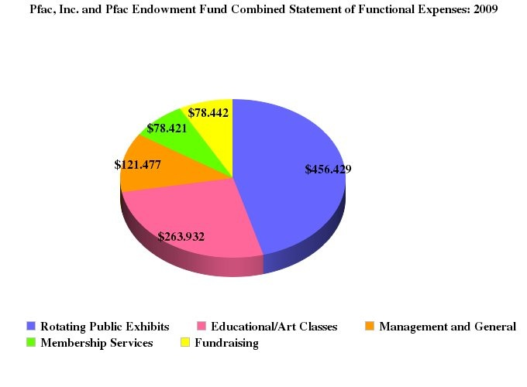

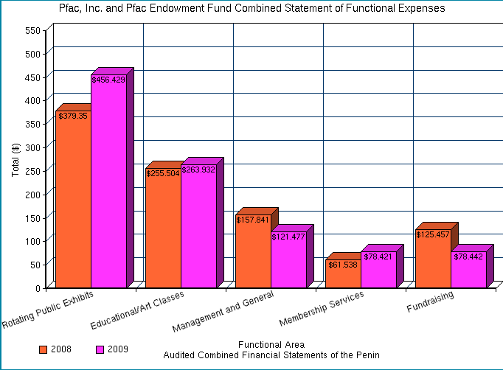

Management-HR

The HR approach to management in a non-profit is geared towards having a highly motivated and determined staff, to successfully implement the goals of the organization. Currently, the Peninsula Fine Arts Center (PFAC) is being operated by six staff members: Courtney Gardner, Executive Director, Michael Andrew Preble, Program Director and Curator, Mike McGrann, Marketing Director, J. Fred Rich, Exhibition/Operations Manager, Janet Hirshman Rash, Art Educator, Joann Dobson, Visitor Services and Debbie Hill, Bookkeeper. As most businesses and organizations do, PFAC does not use local newspapers or any other method to recruit new employees. The Peninsula Fine Arts Center recruits employees through methods of advertisement in emails and word of mouth. PFAC has not had any new hires because the vast majority of their employees have been placed and are functioning well within the organization on their own.

The Peninsula Fine Arts Center gains volunteers and interns, by displaying applications online for potential volunteers to fill. Application questions consist of basic information such as name, birth date, age, address, contact number, level of education, availability and references. The application also consists of short answer questions to gain understanding of the potential volunteer’s interest. The application ends with the potential volunteer signing the volunteer Code of Conduct and for prospect volunteers agreeing to have their background checked. After interns and volunteers are hired, they undergo a docent training; docent trainings are ran regularly due to the frequent exhibit changes.

The Peninsula Fine Arts Center uses 4 to 5 interns per semester and 2 or 3 of the interns are placed in marketing. Most interns come from the local University, Christopher Newport University. Interns are hired as volunteer staff. They are unpaid and reap the benefits by gaining extreme knowledge of the Arts. There are currently 100 volunteers that work 2.5 to 5 hours per week with PFAC. With the help of interns and volunteers, last year PFAC served 28, 311 on-site visitors, 47,600 student art work, 2,257 students enrolled in the art school. Currently, from July 1st to December 31st, they have served 18,585 on-site visitors, 29,294 students K-12 have enrolled, and student enrollment is 731. PFAC does not have a set ethnicity of individuals that they serve; however they keep track of their members by place of residence. As a result, the vast majority (50%) of their volunteers are from the Newport News area.

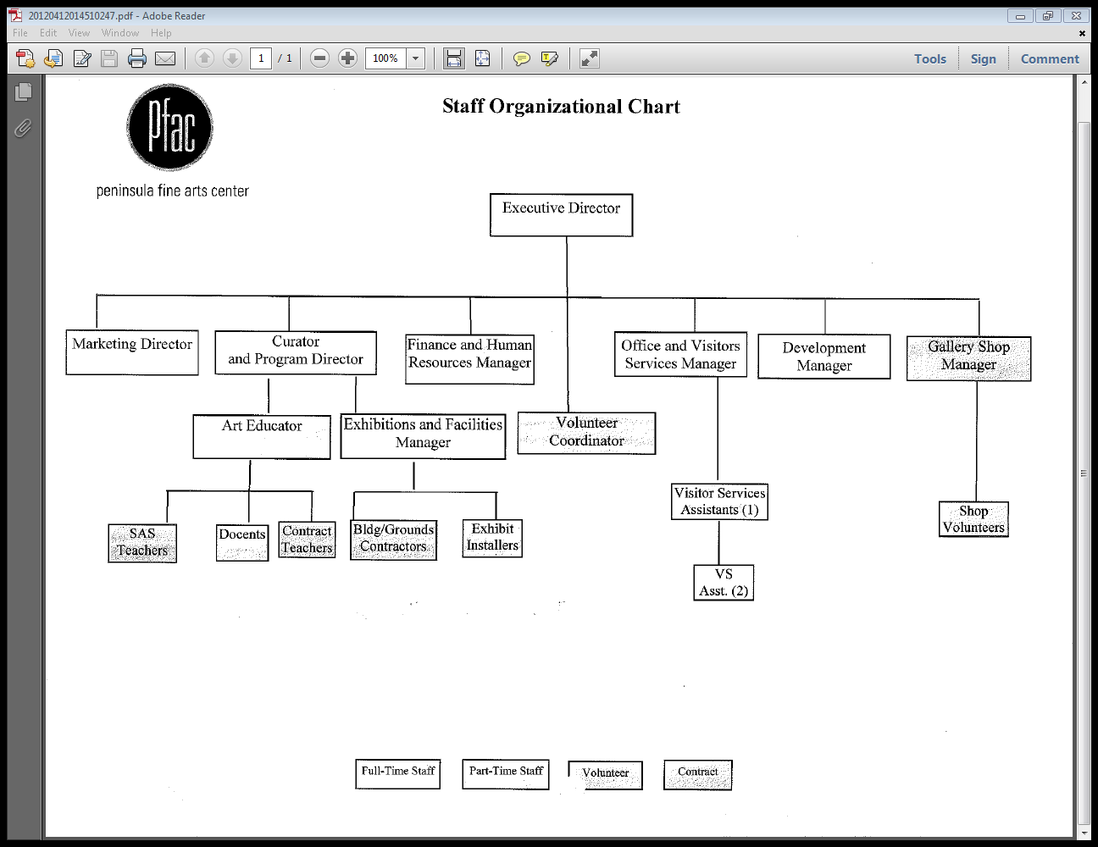

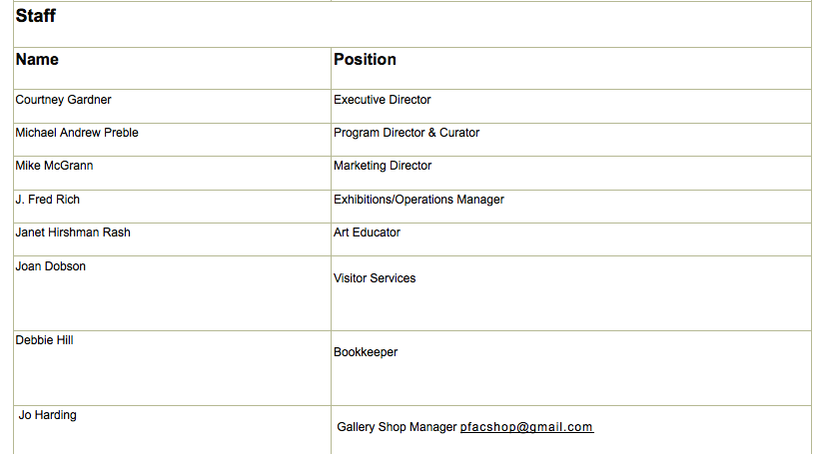

Management-Operations

Another functional area of Non-Profit Management is Management Operations. The operations approach to management in a non-profit requires utilizing a specific technique to achieve goals within the organization. The Peninsula Fine Arts Center has a strategic plan, but does not make use of it. PFAC has various programs that are used to keep interested individuals engaged in the Arts. They also have a very extensive schedule of classes, geared towards different techniques in Art. There is no actual calendar of events on the website, but there is a length of class time and days next to each program or class. If individuals are interested, they have their potential clients fill out registration forms, as a way of record keeping. They currently track and manage members through their "outreach email" list. This method is very effective to PFAC because it references how they monitor not only current volunteers but current and past donors as well. Through email, PFAC sends out a newsletter via email that is called PFAC News". It lists upcoming events, volunteering information, and other things to keep and gain more interested individuals in their organization.

Marketing

The Marketing Strategy for any nonprofit organization is a crucial indicator of the organization’s future success. However, most nonprofits, especially the Peninsula Fine Arts Center, are unable to devote a large portion of money to their marketing efforts. In Pfac’s situation, little to no money is spent purely on marketing ventures. Pfac’s Marketing Coordinator, Mike McGrann, describes Pfac’s budget as meager from the get go. However, he recognizes the importance of the Pfac’s entire budget as a whole, stating that the lack of funding of marketing is a small challenge to over come, considering the institution as a whole is the primary concern of all departments. Regardless of this challenge, Mike has ample experience with marketing endeavors and through his time working for Eddie Bower, has created the marketing strategy of products and experiences. “We are more than just exhibits”, Mike exerts, “we are an experience that we encourage the local community to incorporate into their daily lives”. This stress on focusing on the local community is apparent in more than the just the marketing strategies of Pfac. The art work they display, and sell, the classes that are available and taught, as well as the juried exhibits by students k-12 and colleges exhibit the importance of supporting and sustaining local art. “We want to come back to our roots through our anniversary” Mike says, “back to our community and actively engage local artists with what we do here”. Using gorilla tactics and grass roots ideas, Mike and Pfac have effectively used creativity and passion to fuel their marketing efforts. Pfac uses direct mail, emails, print ads in the Daily Press, flyers (see Appendix for example of flyer) and commercials on the local television station, WHRO, to advertise events and programs at Pfac. These efforts as well as our own recommendations will create the Creative Marketing Strategy for Pfac. Utilizing the strengths of this organization, we have determined the following Creative Marketing Plan:

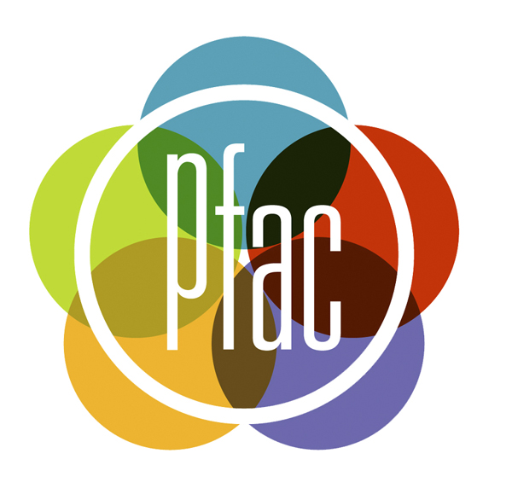
The Peninsula Fine Arts Center has developed an unique and eye catching logo-This logo, called the “Pfac Atom”, is a fully established logo that is hopefully a recognized symbol in the area. The artistic eye may notice that the atom may look like a color wheel or a color swatch, emphasizing that if a consumer did not know what the letters Pfac stood for, they may be able to assume that this symbol represents an arts organization, regardless of having first hand knowledge about Pfac.

Pfac also has a slogan-
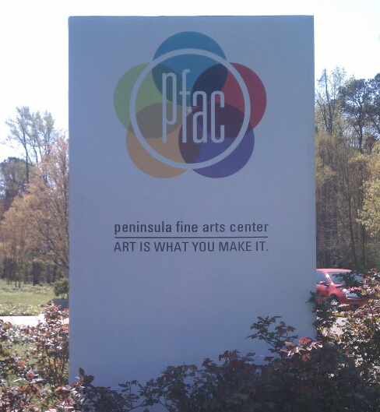
The slogan “Art is what you make it”, is a beautiful tagline that accentuates the diversity and welcoming nature of the Center. This tagline is displayed through internet sources such as the highly informative Pfac website (www.pfac-va.org) and the Pfac Facebook Page which has almost 700 likes (https://www.facebook.com/pages/Peninsula-Fine-Arts-Center-Pfac/132741423419416), as well as the center itself (see picture on left).
The marketing elements that Pfac already owns are creative, unique, and have the necessary components required for future success. Another strength Pfac owns are artists! Having its own personal arsenal of artists, Pfac has no need to hire professional photographers to document the events and activities that frequent the Center. Using this supply of beautiful, high quality photos, our group created our own addition to Pfac’s marketing strategy- Public Service Announcements.

Using the pictures supplied to us by Pfac’s marketing coordinator, Mike McGrann, we created two 60 second and 90 second videos. After creating our own script and recording our voices narrating the benefits of joining Pfac, we added music and words to the beautiful snap shots of Pfac art, events, and participants. These public service announcements were challenging to create, but our group enjoyed the opportunity to be creative and give something tangible to this beautiful organization. The fun really began when we filmed our third 30 second public service announcement, in which we were able to show off our supreme acting skills, by being the stars of the video. Although not as professional or serious as our first two public service announcements, this third video was a blast to make and shows the opportunities that are available in Pfac. We made it clear to Mike and the other employees of Pfac that it is entirely up to them if they would like to utilize this third public service announcement.

In the near future, we would like to utilize the connections Pfac has with the local tv and radio stations to have our public service announcements played on the air! We hope that our videos will encourage people in our community to explore Pfac for themselves. We hope they have an experience as beneficial as ours was. We would also like to make suggestions to Pfac’s future marketing ideas:
- Using their artists: without the help of the beautiful photos supplied to us by Mike, our public service announcements would have been at a severe disadvantage. Use your artists! Organize a contest or encourage other photographers to capture images of Pfac that could be used as flyers or other marketing opportunities. You never know when you could snag a great picture that might catch someone else’s eye.
- Use children!: Create a pinwheel craft with some paper, a crayon, and a popsicle stick. Kids can make their own version of the Pfac logo! Then give them to families to place in their front yards. This marketing is free! And can gather attention in neighborhoods throughout the community.
- Make connections: If Pfac were to host an event with the Mariners Museum, you could utilize their mediums of marketing to advertise your collaborative event. If the Mariners Museum does not wish to share their established marketing methods, perhaps they could donate the funds, and Pfac could supply the creativity! Thus giving you financial wiggle room to create your own marketing ideas.
- Invest in technology: The program we used to create the public service announcements is a very simple program that comes standard with Mac computers. The next time Pfac finds the funds for a technology upgrade or replacement, we would encourage them to purchase a Mac computer, or the newest version of Microsoft Word. Word comes with beautiful templates for newsletters and flyers that members of our group have used very successfully in the past and feel that Pfac could benefit from this simple to use program.

The Peninsula Fine Arts Center has many strengths. Harnessing them in a creative way was a beneficial way for our group to create tangible marketing promotion as well as fuel ideas for the future. To view our public service announcements, please use the following links:

90 second video: http://www.youtube.com/watch?v=tL92DpBixIY&feature=youtu.be
60 second video: http://www.youtube.com/watch?v=k8wKgpk_0Rs&feature=youtu.be
30 second video:
http://www.youtube.com/watch?v=QSS3qRUlCbc
IT

Another functional area of business is IT, where nonprofit organizations make use of technology in their organization. PFAC benefits entirely from this method. PFAC uses their website as a promotional tool. They have a very detailed site that shows the viewer’s their brilliant logo, slogan, extensive schedule of classes, volunteer/intern information and donation forms/links. The Peninsula Fine Arts Center also uses social media Facebook, YouTube, and MySpace.

The Peninsula Fine Arts Center manages their donors via email through a dual process; they label this method as outreach email to keep donors interested in the services PFAC has to offer. PFAC sends out a newsletter called "PFAC News" that drives their members to the website because that is more cost effective for them. They have an active mailing list of 1,523 and an email list that is even larger, which lists all past and present donors and volunteers. They formally mail out letters for events or invites, but not generally as outreach for news on the Arts. Currently, they have currently over 1,000 donors. PFAC has different donor levels. An individual member is valued at $40, family membership is $60, circle member curator and director is $150, and those who donate more than $1000 are called "president" donors.

Legal and Ethical

As stated previously, the Peninsula Fine Arts Center does not have a Code of Ethics reserved specifically for its organization. However, the organization does maintain the same Code of Ethics recognized by most art establishments (refer to Appendix).

The Peninsula Fine Art Center is focused upon the preservation and treatment of its artwork and its artists. As a result, one of the main ethical concerns of the organization is ensuring that all artwork and artists are protected and respected. PFAC ascertains this concern through the retention of a licensed lawyer whom is also a member of the Board of Directors.

Recommendations and Suggested Implementations

The Peninsula Fine Arts Centers is a successful nonprofit organization in the local area of Newport News. However, there are many suggestions and recommendations that need to be made in order for PFAC to further succeed and adhere to its mission and vision.

Priority Recommendations

- State a clear mission on the website. A mission is important because it allows those who are interested in the organization to find out what the organization stands for. Not having a clear or accessible mission or a mission at all could limit individuals from becoming interested or invested in the organization. PFAC needs a clear mission on their website in order to attract more interest to the organization and dedication to its purpose. The mission can be found on the facebook page and on GuideStar. However, it could also benefit from being revised, in order to better communicate the most important aspects of Pfac.

- Have a well-displayed and formatted list of classes on the website. Currently, the class schedule on the website is poorly formatted, which could cause the users to become less likely to visit the class schedule or read about the courses. Developing a calendar, displaying each class on the appropriate day with the time would be beneficial solution. The title displaying the class and time should be capable of linking the viewer to a detailed description of the course, time, and costs. This eliminates having a page full of words detailing the courses, which could possibly confuse those who are interested.

- The website would also benefit from having a complete and up-to-date list of employees.

- Include the 990, an annual report, and code of ethics on the website.

Long Term Recommendations

- Clarify image and perception of Pfac by continuing to reach out and broadening reach to the local community through advertisement.

- Establish effective methods to qualitatively measure success and commitment to mission by measuring outcomes. Methods such as surveys and evaluations may be utilized.
- Edit the strategic plan in order to make it a useful component of the organization.

- Establish and build relationships with community organizations in order to broaden outreach and increase effectiveness. This could be accomplished by partnering on events.

- Create an annual report to help keep individuals up to date with the organization.

- Develop ways to improve advertising so it can be more wide reaching. Continue to build relationships with local newspapers and magazines, and local radio and television stations.

Conclusion

Working with the Peninsula Fine Arts Center has been a rewarding experience for all members of our group. Seeing the passion and drive the staff members have toward their organization, our local community, and the arts as a whole has been inspiring and eye opening. Using methods such as the Seven Sisters (Accounting, Finance, Management Human Resources, Management Operations, Marketing, IT, and Legal and Ethics), and SWOT analysis (Strengths, Weaknesses, Opportunities, and Threats), were very effective in measuring the components of this organization. The most beneficial aspect of this project were our on site visitations. Speaking with Joan, an employee with over 23 years of service to Pfac, showed us how she is more than just a receptionist. Mike McGrann, who puts the creative in Creative Marketing Strategies, enlightened us on how passion can be more valuable than money. Courtney Gardner, the relatively new Executive Director was a source of knowledge about Pfac, CNU, and our area as a whole. Working with Pfac has allowed our lectures to come to life, demonstrating facets of organizational, accounting, and management practices for non-profit organizations.
This 501 ( c ) ( 3 ) was an applicable case study for this course and will be a resource to the members of our group in the future.

Appendix

A) Strategic Planning PowerPoint (Bardwell)
B) Audit Combined Financial Statements
C) 2008 990
D) 2009 990
E) PFAC Volunteer and Intern Application
F) “Art After 5” Advertisement
G) Board Member Responsibilities
H) Smithsonian Institution Statement of Values and Code of Ethics
I) Bylaws of the Peninsula Fine Arts Center
J) Total Visit 2011-2012 Bar Graph
K) Year to Date Bar Graph 1
L) Year to Date Bar Graph 2
M) Website
N) Power Point

(2011). Pfacts Newsletter.
S. H. Bardwell. (2012). Understanding the seven sisters to economic success. An Introduction to the Seven Sisters. Chapter One, p. 2.
S. H. Bardwell. (2012). Understanding the seven sisters to economic success. An Introduction to the Seven Sisters. Chapter One, p. 2.

